**PRACTICE 2**

mysql> create database orders;

Query OK, 1 row affected (0.14 sec)

mysql> use orders;

Database changed

mysql> create table orders(ord_no int primary key,p urch_amt double,ord_date varchar(10),customer_id int,salesman_id int);

Query OK, 0 rows affected (0.43 sec)

mysql> insert into orders values(70001,150.5,'2012-10-05',3005,5002);

Query OK, 1 row affected (0.14 sec)

mysql> insert into orders values(70009,270.65,'2012-09-10',3001,5005);

Query OK, 1 row affected (0.15 sec)

mysql> insert into orders values(70002,65.26,'2012-10-05',3002,5001);

Query OK, 1 row affected (0.06 sec)

mysql> insert into orders values(70004,110.5,'2012-08-17',3009,5003);

Query OK, 1 row affected (0.13 sec)

mysql> insert into orders values(70007,948.5,'2012-09-10',3005,5002);

Query OK, 1 row affected (0.14 sec)

mysql> insert into orders values(70005,2400.6,'2012-07-27',3007,500);

Query OK, 1 row affected (0.09 sec)

mysql> insert into orders values(70008,5760,'2012-09-10',3002,5001);

Query OK, 1 row affected (0.10 sec)

mysql> insert into orders values(70010,1983.43,'2012-10-10',3004,5006);

Query OK, 1 row affected (0.22 sec)

mysql> insert into orders values(70003,2480.4,'2012-10-10',3009,5003);

Query OK, 1 row affected (0.17 sec)

mysql> insert into orders values(70012,250.45,'2012-06-27',3008,5002);

Query OK, 1 row affected (0.15 sec)

mysql> insert into orders values(70011,75.29,'2012-08-17',3003,5007);

Query OK, 1 row affected (0.12 sec)

mysql> insert into orders values(70013,3045.6,'2012-04-25',3002,5001);

Query OK, 1 row affected (0.12 sec)

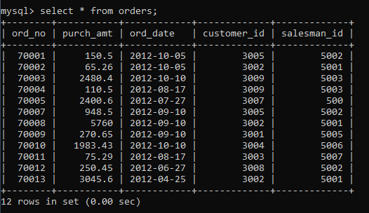

**1.From the following table, write a SQL query to calculate total purchase amount of all orders. Return total purchase amount.**

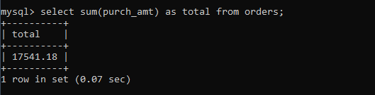

**2.From the following table, write a SQL query to calculate the average purchase amount of all orders. Return average purchase amount.**

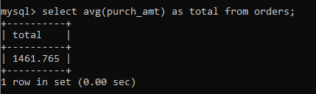

**3.From the following table, write a SQL query that counts the number of unique salespeople. Return number of salespeople.**

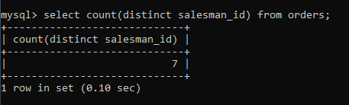

**4. From the following table, write a SQL query to find the maximum purchase amount.**

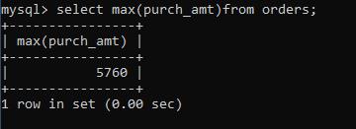

**5.From the following table, write a SQL query to find the minimum purchase amount**.

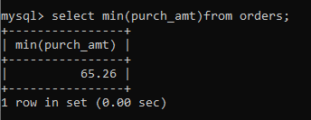

**6. From the following table, write a SQL query to find the highest purchase amount ordered by each customer. Return customer ID, maximum purchase amount.**

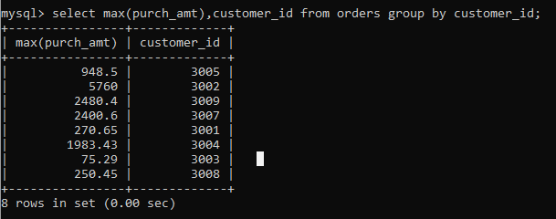

**7.From the following table, write a SQL query to find the highest purchase amount ordered by each customer on a particular date. Return, order date and highest purchase amount.**

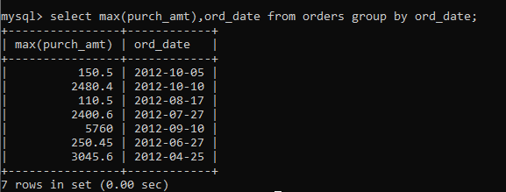

**8.From the following table, write a SQL query to determine the highest purchase amount made by each salesperson on '2012-08-17'. Return salesperson ID, purchase amount**

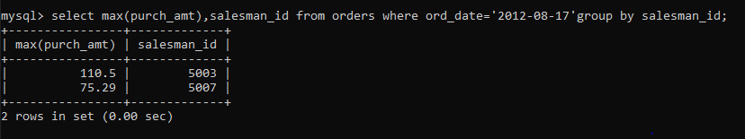

**9. From the following table, write a SQL query to find the highest order (purchase) amount by each customer on a particular order date. Filter the result by highest order (purchase) amount above 2000.00. Return customer id, order date and maximum purchase amount.**

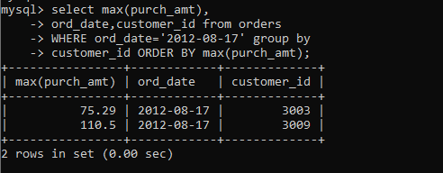

**10.From the following table, write a SQL query to find the maximum order (purchase) amount in the range 2000 - 6000 (Begin and end values are included.) by combination of each customer and order date. Return customer id, order date and maximum purchase amount.**

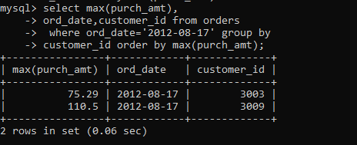

**11.From the following table, write a SQL query to find the maximum order (purchase) amount based on the combination of each customer and order date. Filter the rows for maximum order (purchase) amount is either 2000, 3000, 5760, 6000. Return customer id, order date and maximum purchase amount.**

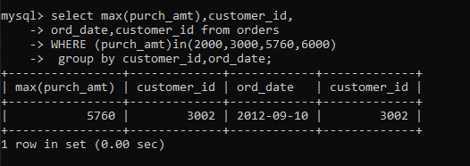

**12.From the following table, write a SQL query to determine the maximum order amount for each customer. The customer ID should be in the range 3002 and 3007(Begin and end values are included.). Return customer id and maximum purchase amount.**

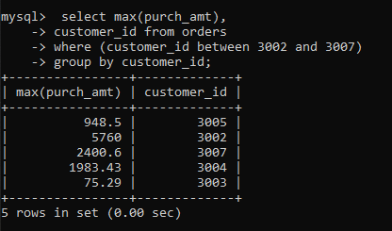

**13.From the following table, write a SQL query to find the maximum order (purchase) amount for each customer. The customer ID should be in the range 3002 and 3007(Begin and end values are included.). Filter the rows for maximum order (purchase) amount is higher than 1000. Return customer id and maximum purchase amount.**

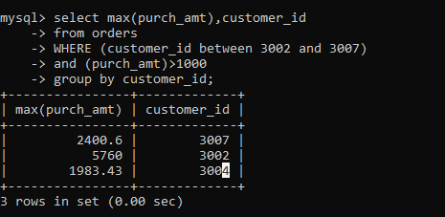

**14. From the following table, write a SQL query to determine the maximum order (purchase) amount generated by each salesperson. Filter the rows for the salesperson ID is in the range 5003 and 5008 (Begin and end values are included.). Return salesperson id and maximum purchase amount.**

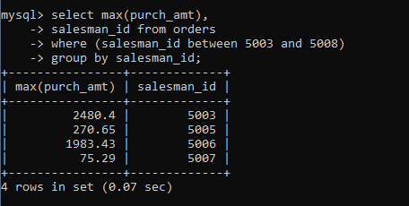

**15. From the following table, write a SQL query to count all the orders generated on '2012-08- 17'. Return number of orders.**

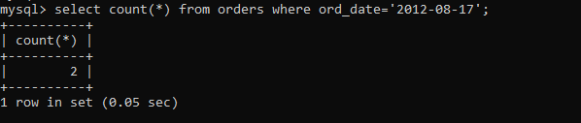

**16. From the following table, write a SQL query to count the number of orders based on the combination of each order date and salesperson. Return order date, salesperson id.**

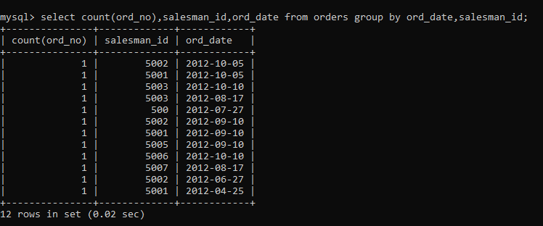

**17. Write a query to display the columns in a specific order,**

**such as order date, salesman ID, order number, and purchase amount**

**for all orders.**

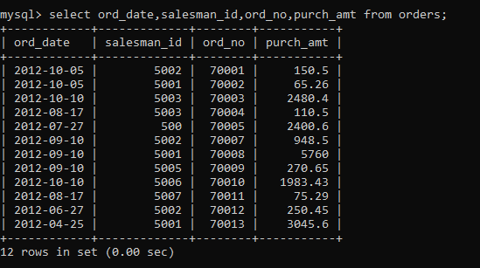

**18. From the following table, write a SQL query to identify the unique salespeople ID. Return salesman_id.**

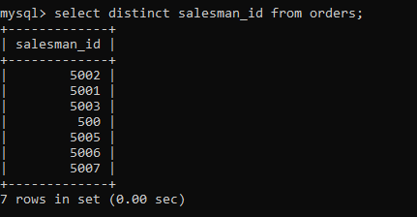

**19. From the following table, write a SQL query to find orders that are delivered by a salesperson with ID. 5001. Return ord_no, ord_date, purch_amt.**

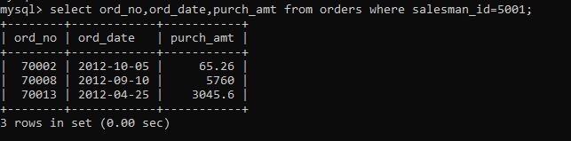

**20. From the following table, write a SQL query to find all the orders. Sort the result-set in ascending order by ord_no. Return all fields.**

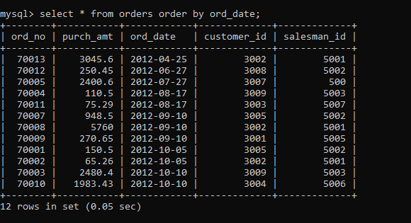

**21.From the following table, write a SQL query to find all the orders. Sort the result-set in descending order by ord_date. Return all fields.**

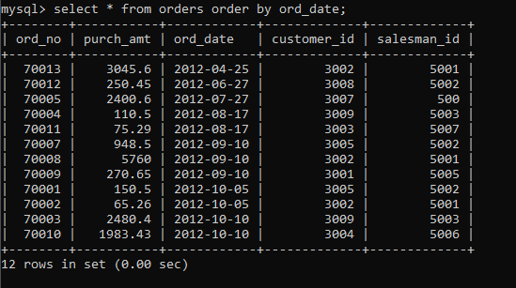

**22. From the following table, write a SQL query to find all the orders. Sort the result-set in descending order by ord_ date and purch _amt. Return all fields.**

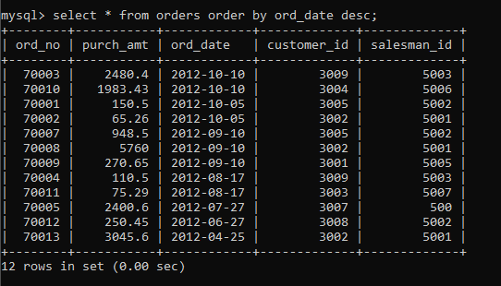

**23. From the following table, write a SQL query that calculates the maximum purchase amount generated by each salesperson for each order date. Sort the result-set by salesperson id and order date in ascending order. Return salesperson id, order date and maximum purchase amount.**

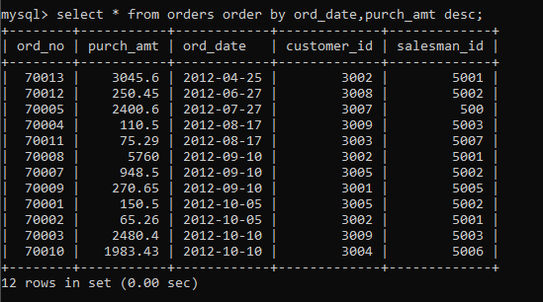

**24.From the following table, write a SQL query that counts the unique orders and**

**the highest purchase amount for each customer.**

**Sort the result-set in descending order on 2nd field.**

**Return customer ID, number of distinct orders and**

**highest purchase amount by each customer.**

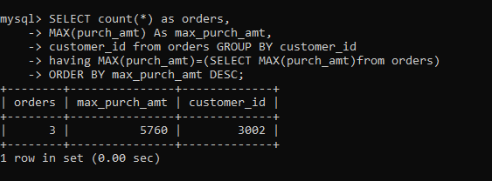

**25.From the following table, write a SQL query to calculate the summation of purchase amount, total commission (15% for all salespeople) by each order date. Sort the result-set on order date. Return order date, summation of purchase amount and commission.**

